Assignment 2
Sumedh Bagade

Pull index file from 2026Q1 branch of remote repository and deploy webpage using apache httpd.

Steps:
- Login to EC2 instance. This will be our jenkins master
- Install Java 17, apache tomcat 10 and git.
- Configure jenkins by downloading latest jenkins.war file and placing it in apache tomcat home/webapps
- Start apache tomcat 10 by running ./startup.sh in /bin of apache home
- Access Jenkins dashboard using public ip of your instance and configure user account.
- On our github we have remote repository named jenkins. This is private repository containing two branches. 2026Q1 branch has our required index file. To clone this to our master we first need to setup credentials in our jenkins dashboard.

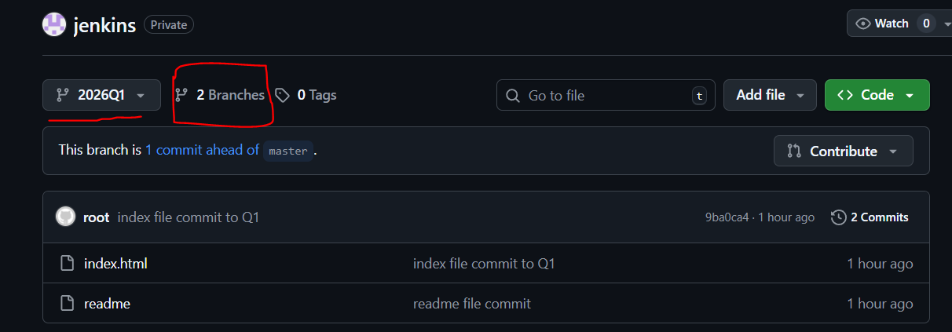

- Go to manage jenkins > security > credentials and create new credentials to access github through git plugin. Here we mention our github username and token.
- Now create a job. In source code management select git plugin and copy the URL of our remote repo. Select the credentials we created earlier. As our index file is in 2026Q1 branch we mention this name in branch specifier so that this branch is cloned in workspace of our jenkins master
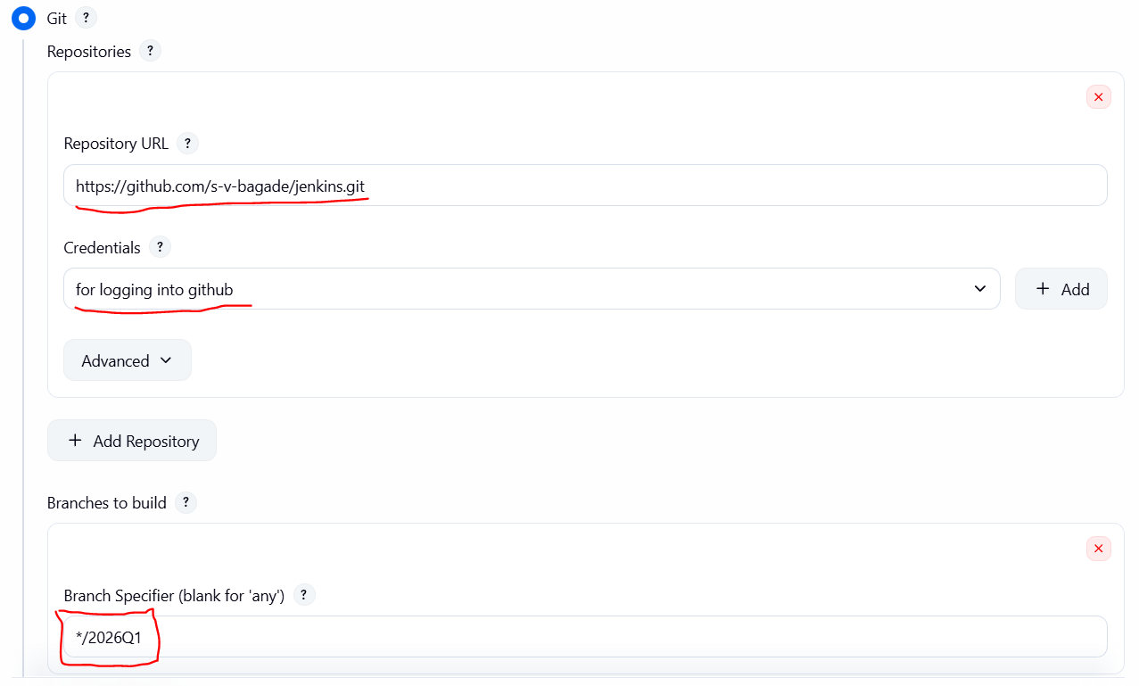
- In Build steps add shell script to configure apache httpd and copy index file to /var/www/html script for this is as follows

yum install httpd -y
systemctl start httpd
cd /var/www/html
cp /root/.jenkins/workspace/job1/index.html .
chmod 777 index.html
systemctl restart httpd

- Create build, If successful access the webpage using http://instance public ip:80

